API Endpoint as a Resource

📝Definition
# Source: AI Source: Provided by: [Data Path: Persons Table -> ID Column: 1, Name_En Column: Motasem Essam] -> From: [ChatGPT] on [1/23/2026]
An API Endpoint is considered a resource in software architecture because it provides access to data or services for other components of the application or external clients. It acts as a controlled entry point to the system’s functionality.
Think of an API Endpoint as a doorway to a resource — it allows other parts of the app (or external systems) to request or modify data.

🔑 Key Points
- Represents a specific functionality or data access point in your system
- Can be internal (used by your app’s own modules) or external (exposed to clients)
- Often interacts with Controllers, Services, and Models
- Keeps business logic separate from data access

🧱 Examples

1️⃣ REST API Endpoint
# Source: AI Source: Provided by: [Data Path: Persons Table -> ID Column: 1, Name_En Column: Motasem Essam] -> From: [ChatGPT] on [1/23/2026]
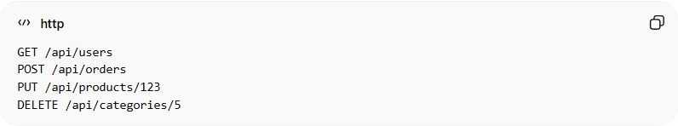
GET /api/users
POST /api/orders
PUT /api/products/123
DELETE /api/categories/5
- Each endpoint corresponds to a resource (Users, Orders, Products, Categories)

2️⃣ Laravel Example
# Source: AI Source: Provided by: [Data Path: Persons Table -> ID Column: 1, Name_En Column: Motasem Essam] -> From: [ChatGPT] on [1/23/2026]
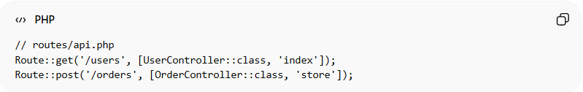
// routes/api.php
Route::get('/users', [UserController::class, 'index']);
Route::post('/orders', [OrderController::class, 'store']);
- /users and /orders are API Endpoint resources
- Controllers handle the logic, Resources format the output

❌ Bad Example
# Source: AI Source: Provided by: [Data Path: Persons Table -> ID Column: 1, Name_En Column: Motasem Essam] -> From: [ChatGPT] on [1/23/2026]
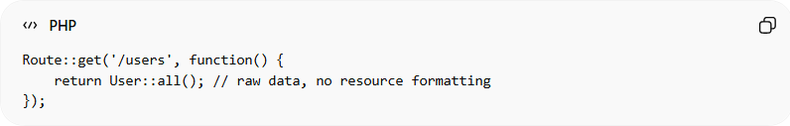
Route::get('/users', function() {
return User::all(); // raw data, no resource formatting
});
Problems:
- Exposes raw data directly
- Hard to maintain or format consistently
- Breaks separation of concerns

✅ Good Example
# Source: AI Source: Provided by: [Data Path: Persons Table -> ID Column: 1, Name_En Column: Motasem Essam] -> From: [ChatGPT] on [1/23/2026]
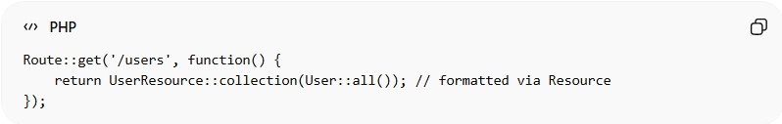
Route::get('/users', function() {
return UserResource::collection(User::all()); // formatted via Resource
});
- Returns structured, reusable data
- Keeps presentation logic separate from controller and model
- Maintains clean and consistent API

💡 Summary:
# Source: AI Source: Provided by: [Data Path: Persons Table -> ID Column: 1, Name_En Column: Motasem Essam] -> From: [ChatGPT] on [1/23/2026]
An API Endpoint as a Resource is a controlled access point to data or services, often paired with Controllers and Model/Domain Resources to keep the system modular and maintainable.

